Brady Meyers

CS-319-H6812

18 July 2021

3-3 Milestone: Paper Prototype

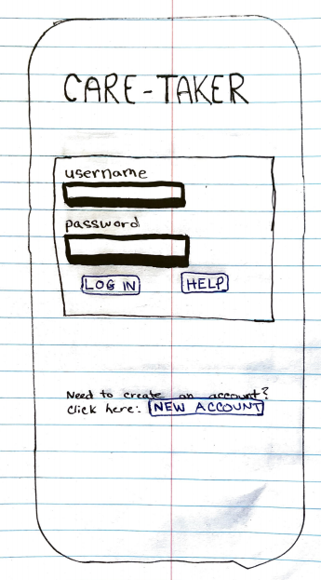

Upon opening the Care-Taker app, users will be greeted with a login screen. They will log in using username and password credentials. They are able to select “help” which will allow them to reset their password or speak to someone for support and they are able to press “new account” to create an account if it is their first time with the service.

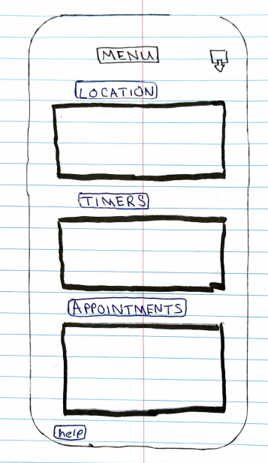

This is the screen shown upon login. There is a menu title at the top, with a button on the top right of the screen to press to logout. The buttons able to be pressed are in blue (which did not turn out well on the scan). Under each button there is a preview screen which has a summary of the information that can be found for each section.

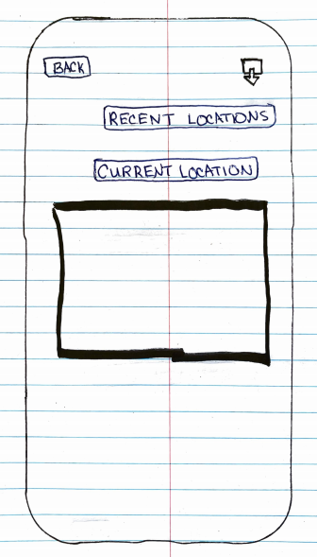

This is the screen that shows when pressing the “Location” button. It will allow you to press two different buttons- “Recent Locations” and “Current Location” which will take the user to each respective screen. Under current location there is a preview window which shows the summary information. Again, the buttons able to be pressed were blue but did not scan well. Additionally, there are two buttons at the top. The “Back” button takes users to the main menu, while the top right button allows the user to logout.

**Feedback From Interviews**

From the interviews I held with my prototype, I was able to capture some very helpful feedback. I was very surprised at the two totally different perceptions and advice/recommendations for the prototype. Person 1 enjoyed that I had a physical back button, as well as buttons that took the user to a new screen each time they were pressed. Person 2 said they would have liked to have seen “drop-down” style menus, where pressing a menu option drops down the information of the respective button. They also would have preferred to have swipe controls, like swiping a finger from the left side of the screen to the right in order to go back a page. Both users interviewed would have liked to have seen how the tracking location will work, and would have liked to have seen a sample notification of “if something went wrong”. Both people were interested in knowing the full color scheme of the app, as well. After hearing feedback about color schemes already, I considered making an option to change the entire theme of the app, similar to how some IDE’s allow the user to pick between a variety of color themes. Although it is difficult to say exactly what changes I will lean toward making at this current moment, I certainly want to incorporate a variety of changes from each person’s feedback.